Genio chat  
  
A simple web based application developed using **React.js**. The App consists of multi components which are nested together to produce single page app.

**App Components**

* Container
* ChatBox
* ChatForm
* Message

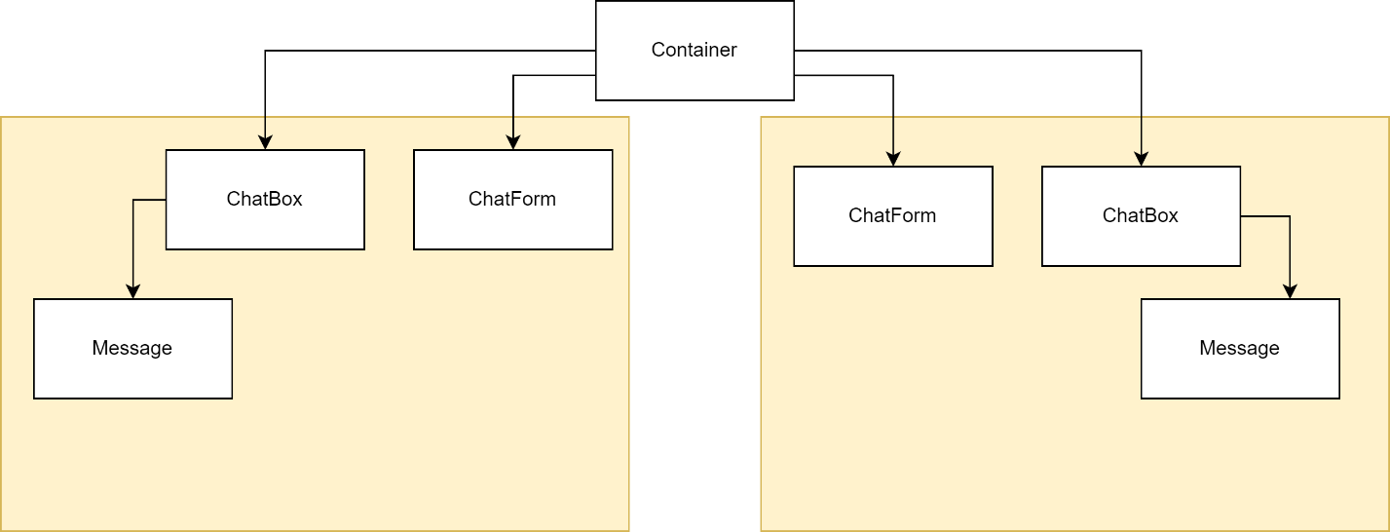The hierarchy of the Components

Functionalities of the App

**Chat alignment** of messages depends on how is the sender and how the Reciver. This was implemented based on specific value in the messages array “**sendby**”.

**Human Friendly Datetime**. This was done using npm package called react-moment

**Close and open chat box button.** A toggle button used to hide or show the chat box based on the status of Booleanvariable**.**

**Unseen badge.** Label used to show number of unseen messages while the chat box close.

Message Reaction. When the user move the mouse over the message text a popup will appear to allow the user to make reaction on the message.